

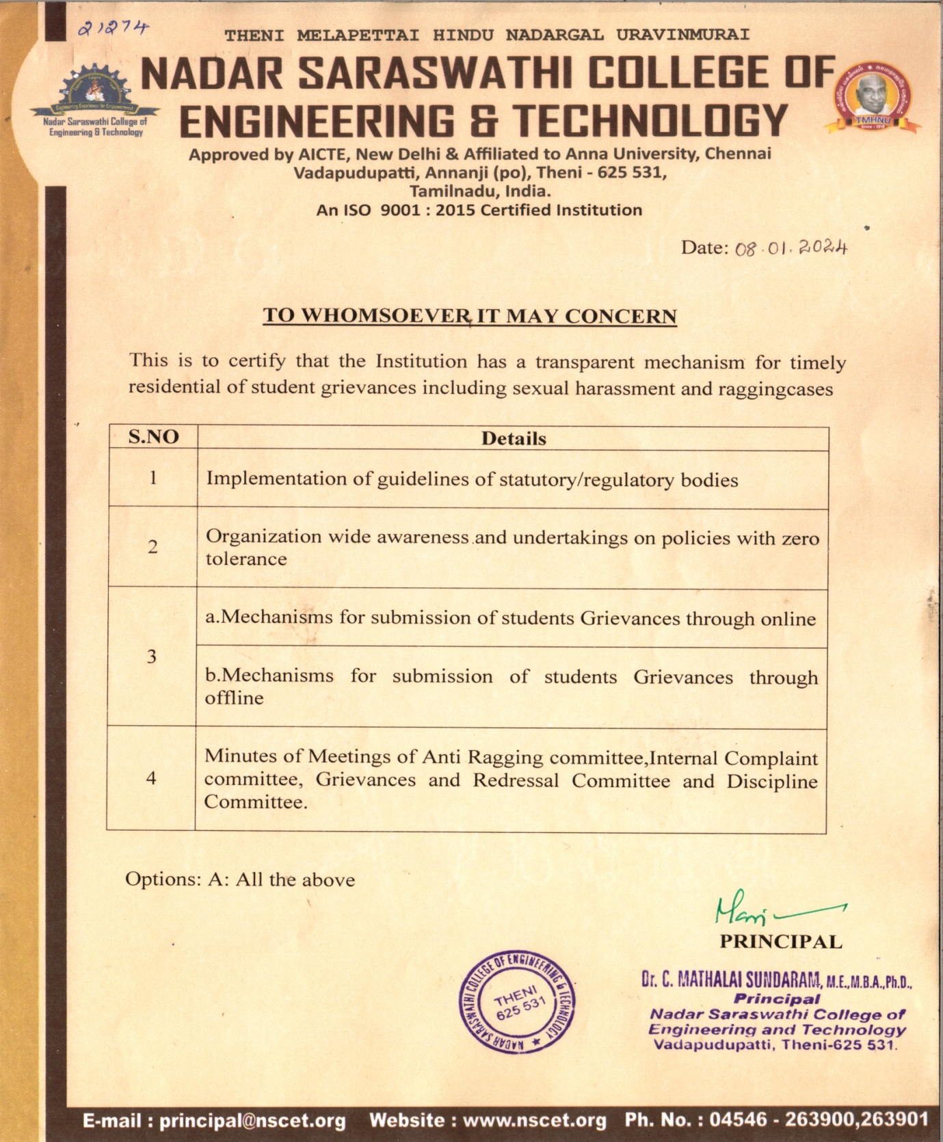



5.1.4. Details of statutory/regulatory Committees

INDEX

| SI.NO | COMMITTEE NAME | LINK |
| --- | --- | --- |
| 1. | Anti-Ragging Committee and Anti-Ragging Squad | [VIEW](https://nscet.org/Welfare%20cells/anti_ragging.php) |
| 2 | Students Grievances and Redressal Committee | [VIEW](https://nscet.org/Welfare%20cells/grievance.php) |
| 3 | Internal Complaints Committee | [VIEW](https://nscet.org/Welfare%20cells/internal_complaient.php) |
| 4 | SC/ST Committee | [VIEW](https://nscet.org/Welfare%20cells/scst.php) |



